Agenda- Integrate Zoom with Pega and Schedule Meetings

So for this first, you need to navigate to the below link which is in the marketplace to Zoom

<https://marketplace.zoom.us/>

and then you need to sign up/log in and then   
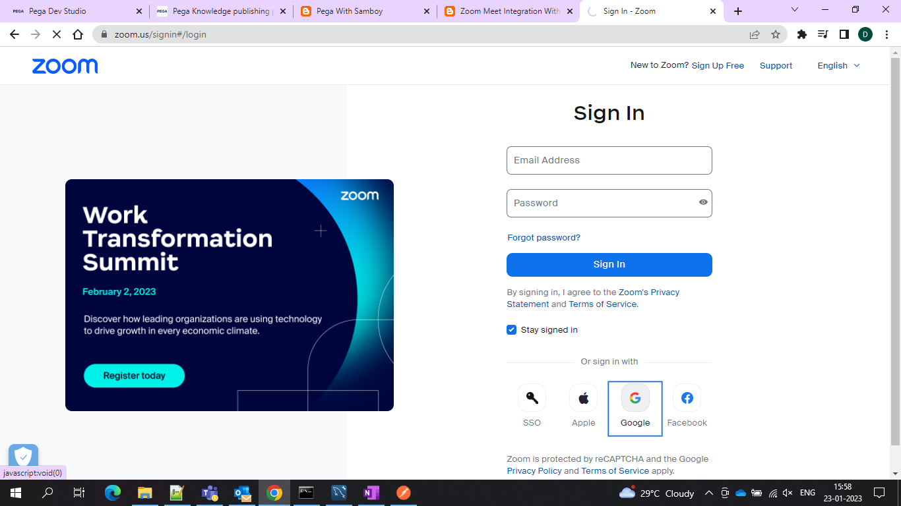

Click on build/develop an app

and after that select OAuth App

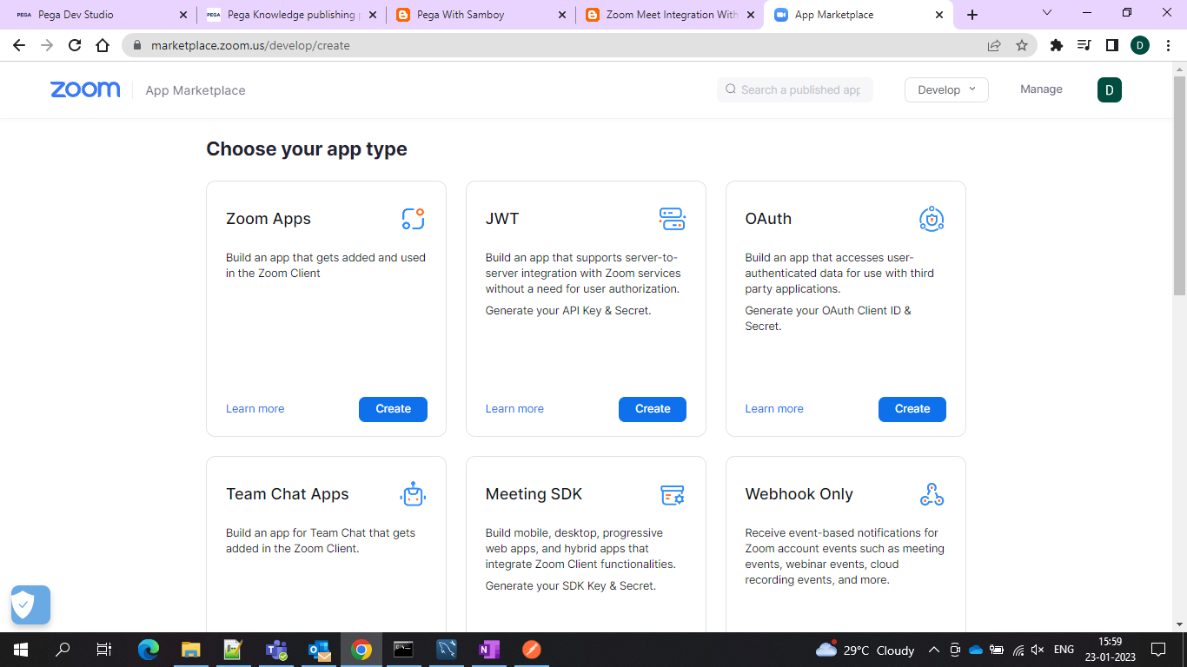

And after that name your app I named as Test and now copy your client ID and client Secret which would be useful for integration in the later steps then you need to provide redirect URL as <http://localhost:8080/prweb/PRRestService/oauth2/v1/redirect>   
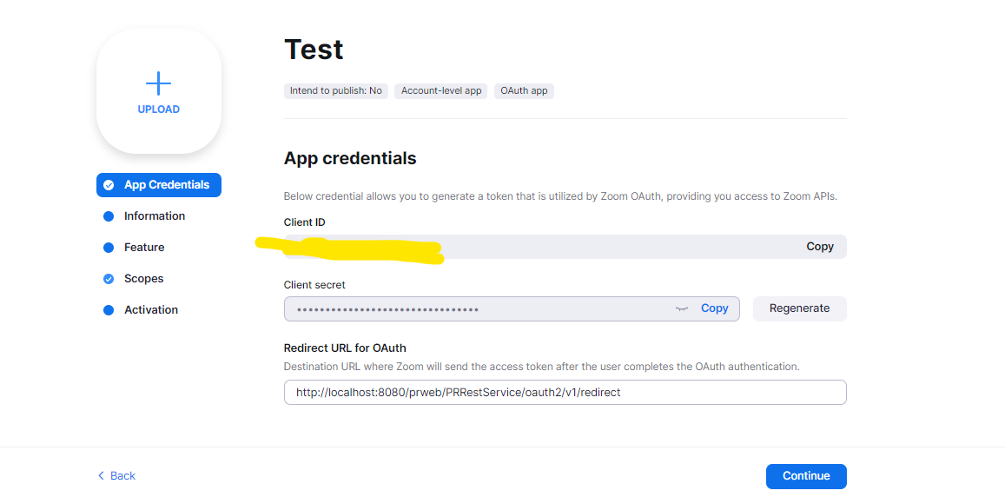

and navigate to the

Information tab and provide description App Name is already taken

You can skip the feature and navigate to the scope tab and under the meeting, scope add the following three checkboxes

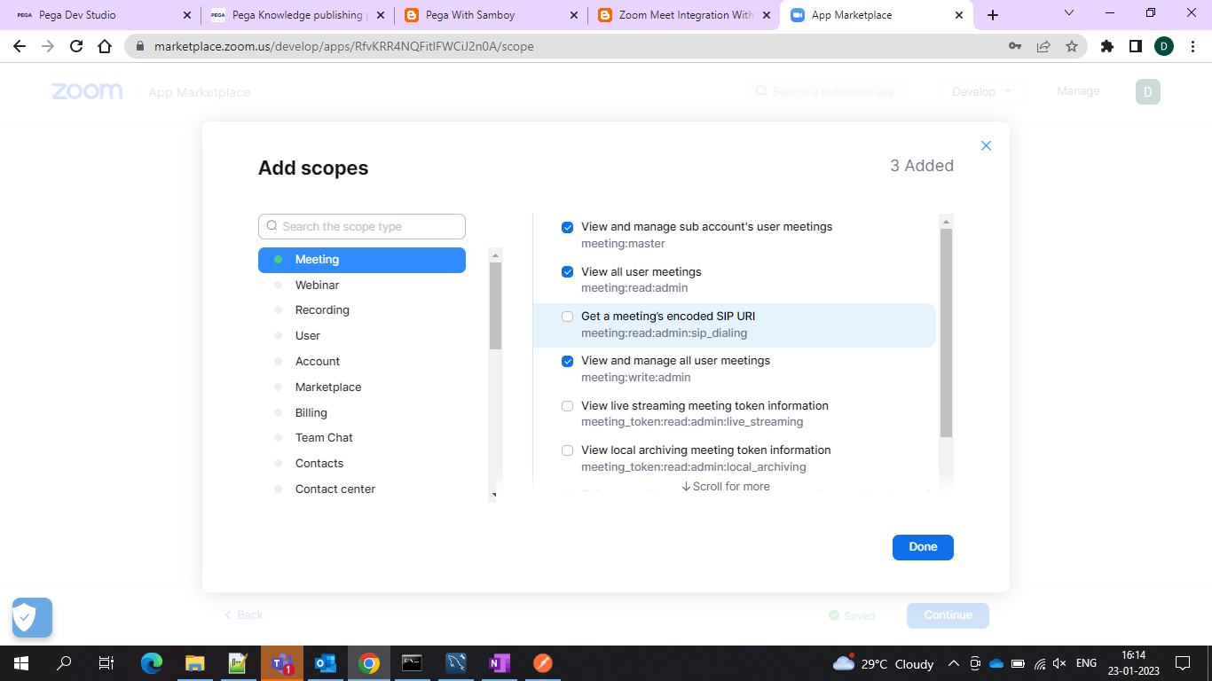

And under the user scope select these 3 checkboxes. that’s it Now let’s get into Pega Part..

Now In Pega create one Authentication Profile under the type Oauth 2.0

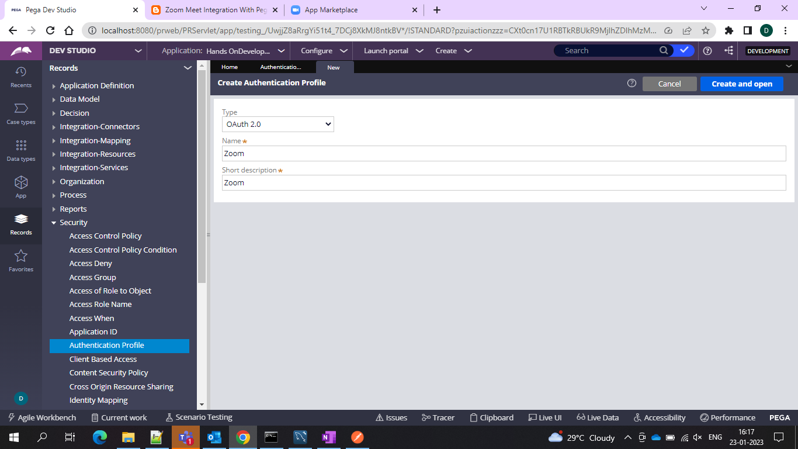

And under that use the grant type as authorization code and the client identifier and the client secret which you already copied from zoom

And under the scope use the scope include as “meeting:write:admin”

And tick the checkbox use refresh token if available

And in the authorization code endpoint use <https://zoom.us/oauth/authorize>

And in the access token endpoint use <https://zoom.us/oauth/token>

And in the redirect endpoint URL use <http://localhost:8080/prweb/PRRestService/oauth2/v1/redirect>

And then start with rest Integration

Configure> integration> REST Integration and go with the wizard

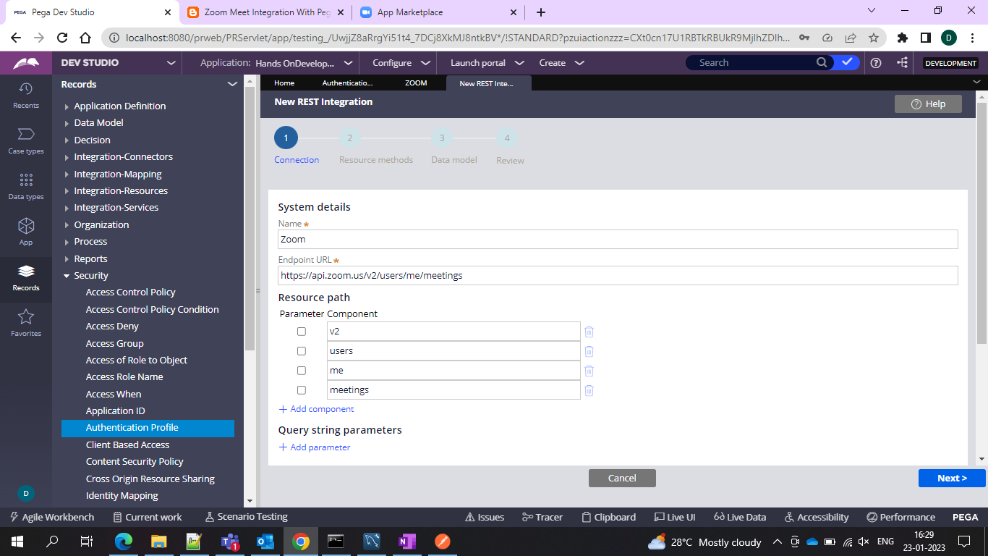

And in the endpoint URL use the <https://api.zoom.us/v2/users/me/meetings>

And in the authentication use the previously created Authentication Profile

And make sure to connect and after that you would see the disconnect option..

If you see this that means you are xuccessfully connected with zoom..

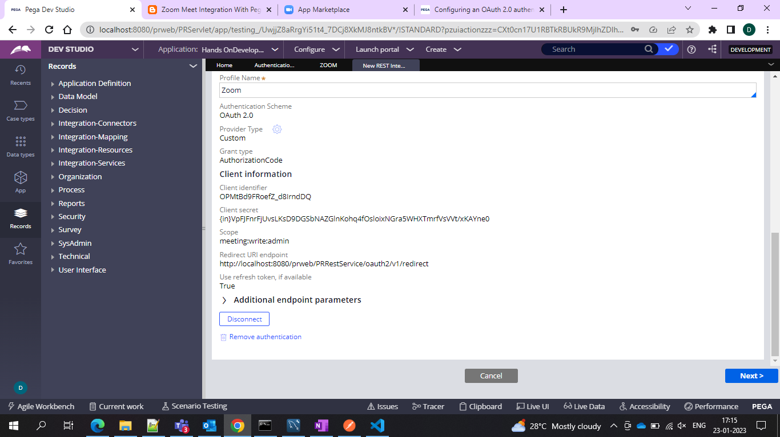

And In your authentication profile you would see a warning that it is being used…

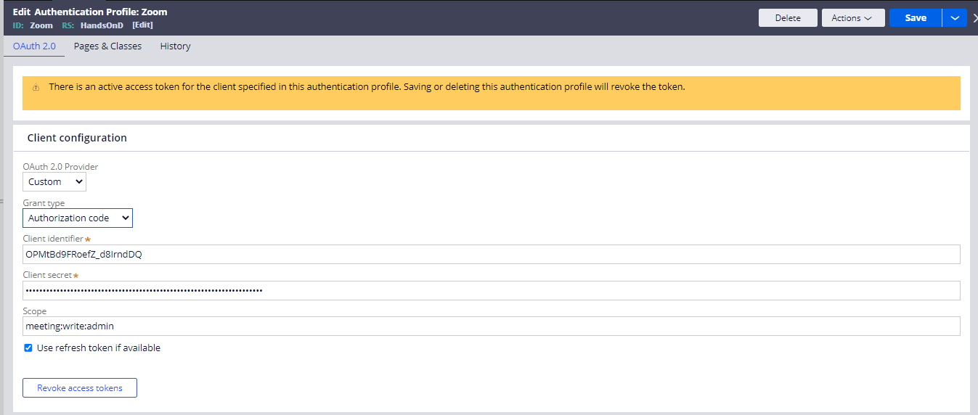

And use the GET and POST response and click next

And after that click next in the integration and use the following code the capture the JSON response

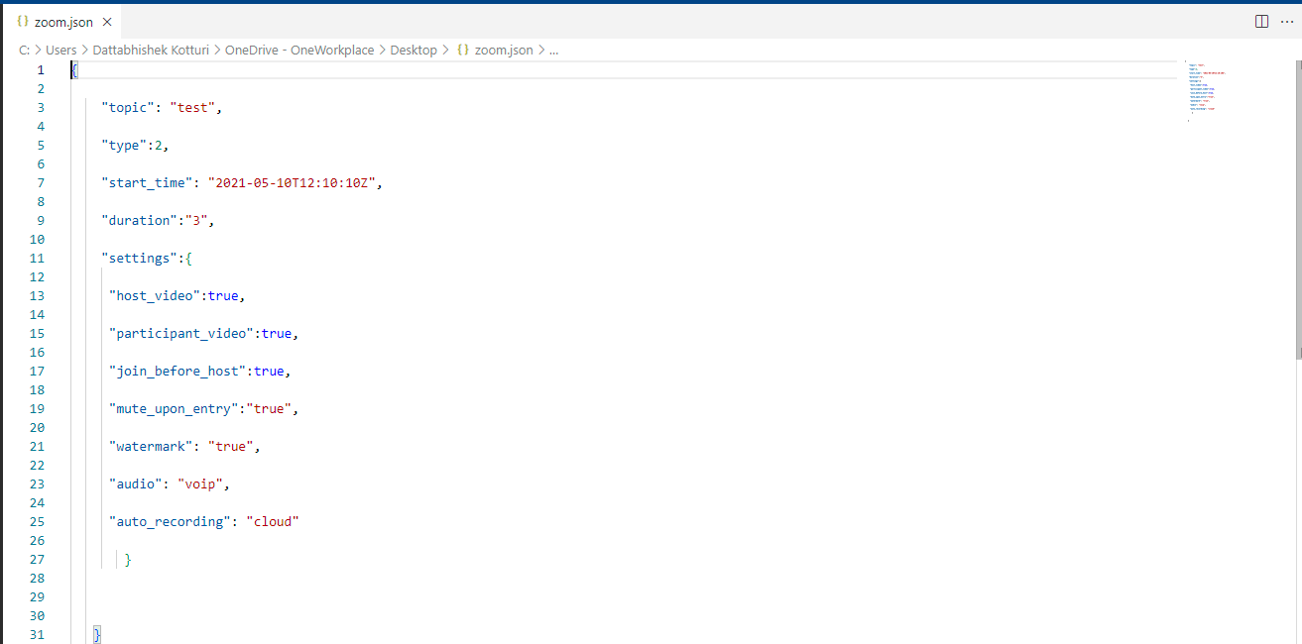

And then use this and save the file to a location on your PC and then in the rest response click add a file and select the POST and request and add the file…

And you would be seeing 201 code… which means it successful… If you see 400 code it means it is error..

And then click create and the integration wizard Starts

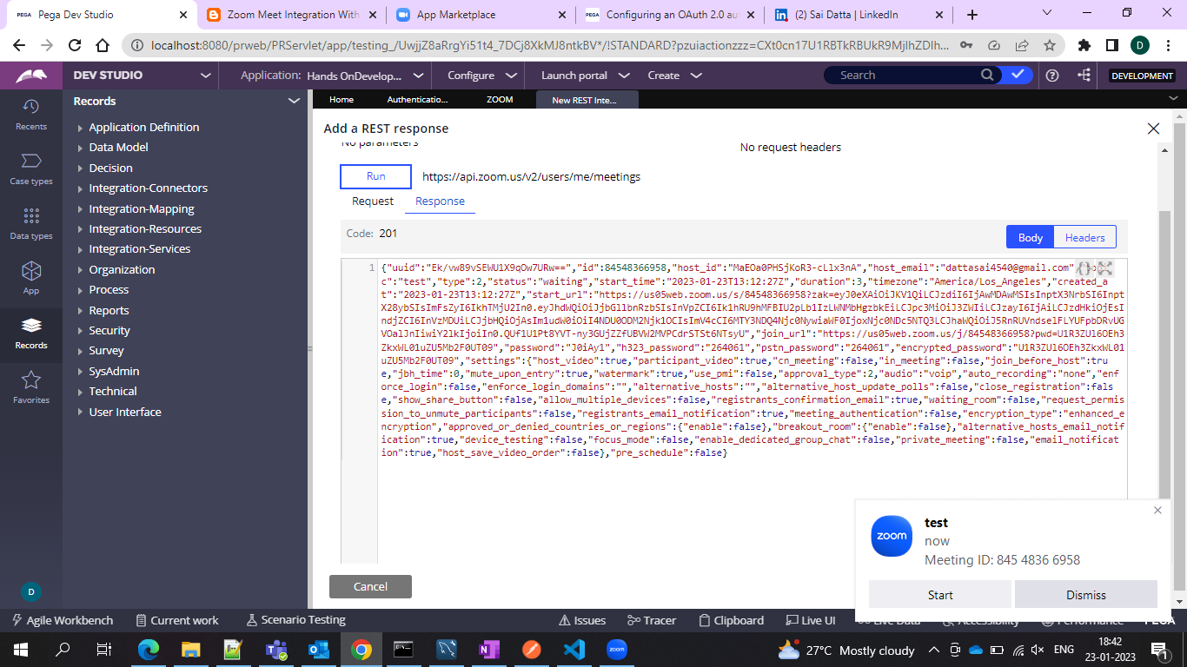

And as soon as the Response is given as you can see zoom pp up is showing to join in the meeting with meeting ID

And once the wizard is done then request and response DT are created.. along with the data page..

So once you run the data page it will schedule another meeting…

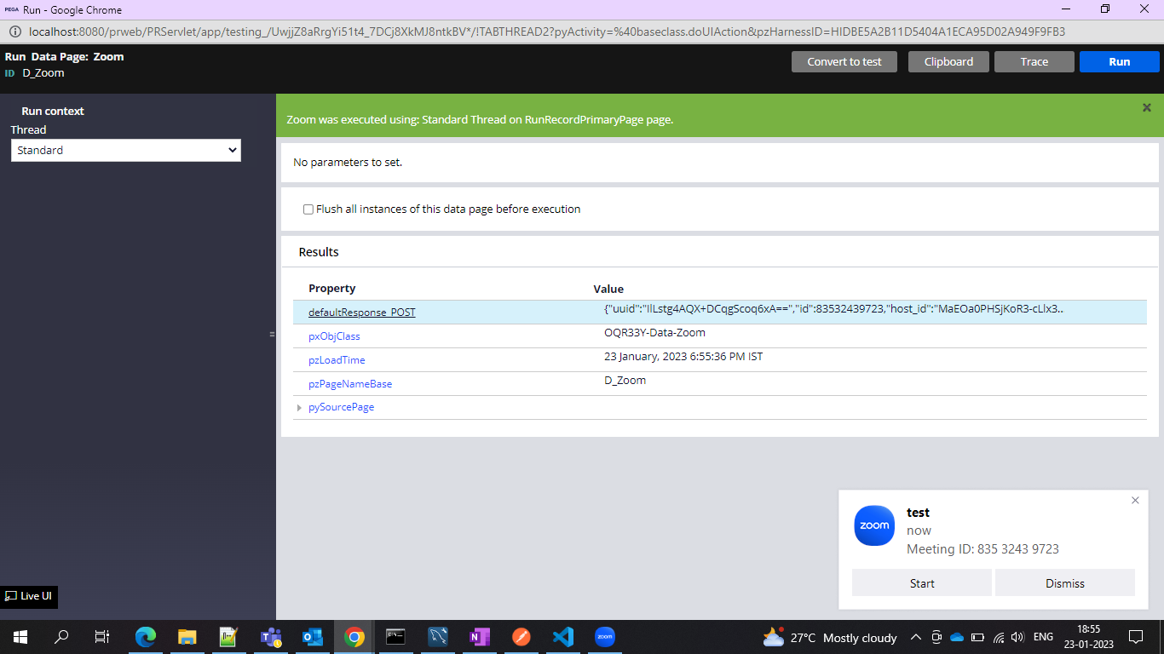

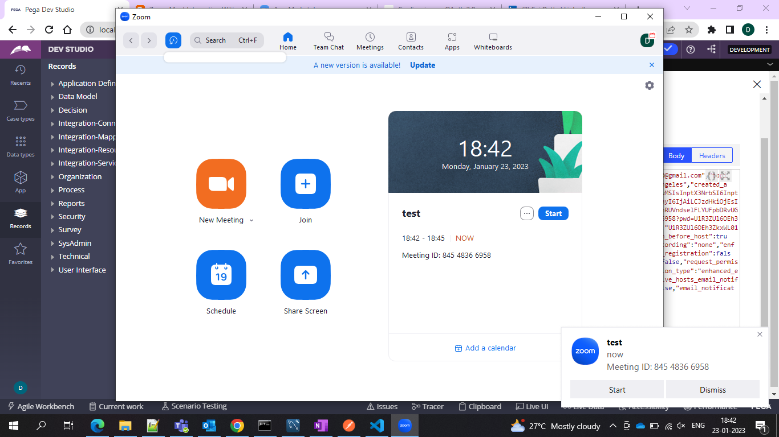

Optional-And you can further show this on the UI by using a button on click of A button you can use an activity which will internally include the connect-REST method and pass your method named in the required fields of the method…

And you can show on your portal as per your convenience or requirement…